**Home Access Center (HAC)**

**Viewing Student Grades**

**PK – 5th Grade**

If you are **not a current user** of Home Access Center (HAC), you will need to visit your child’s campus to obtain a Home Access Center account.

You must have a valid email address to obtain an account to view grades for students in PK-5th grades.

**Sign into HAC:**

<https://denhac2.dentonisd.org/HomeAccess/>

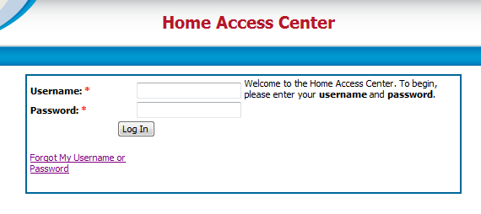

**If you have more than one student attached to your account, you will first need to select the student you want to view grades for.**

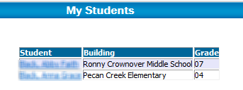

**NOTE:** If you have only one student you will not see the above “**My Students**” list.

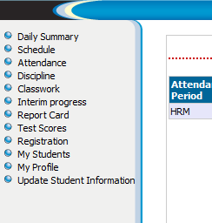

To view **current grade** and assignments, click on **Classwork**.

**Interim Progress** gives you data on the 3rd week Progress Report.

**Report Card** view gives you access to the six week grade average.